overview

* Purpose of choosing this project
* Benefits of this project
* Benchmark analysis
* Summary table
* Site map
* Mock up
* **Diagrams**
* Context
* Data flow
* Activity
* Swim lane
* Use case
* Feasibility study
* Cash flow
* conclusion

**PURPOSE OF CHOOSING THIS PROJECT**

* Why are we doing this project?

* to sell books and service online

* is an online market place for books

Mission :

* our mission is to help people find and buy any types of book from Granthalay. Our business stretches around the country .It remains a company with a passion for books.

**Benefits of this project:**

* Easy to buy books
* Large number of book collection
* Time saving and home delivery
* Opportunity to shop 24/7
* No crowds
* Price comparison

**Benchmark products Analysis:**

* Rokomari.com(national)
* Boibazar.com(national)
* Betterworldbooks.com(international)

**BENCHMARK PRODUCT’S FEATURE: books**

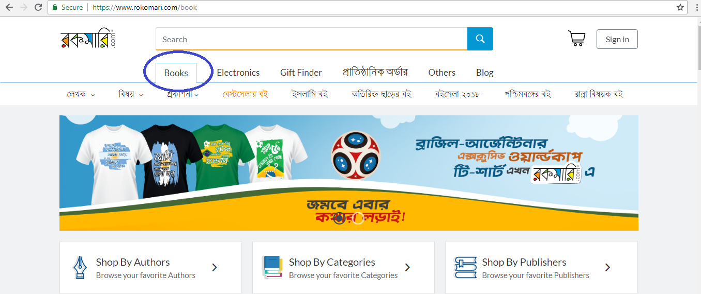

**BENCHMARK PRODUCT’S FEATURE**

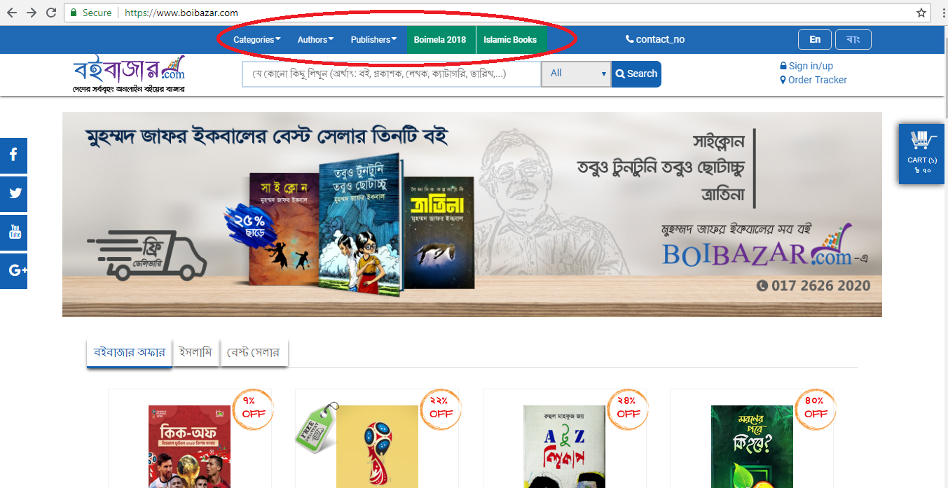

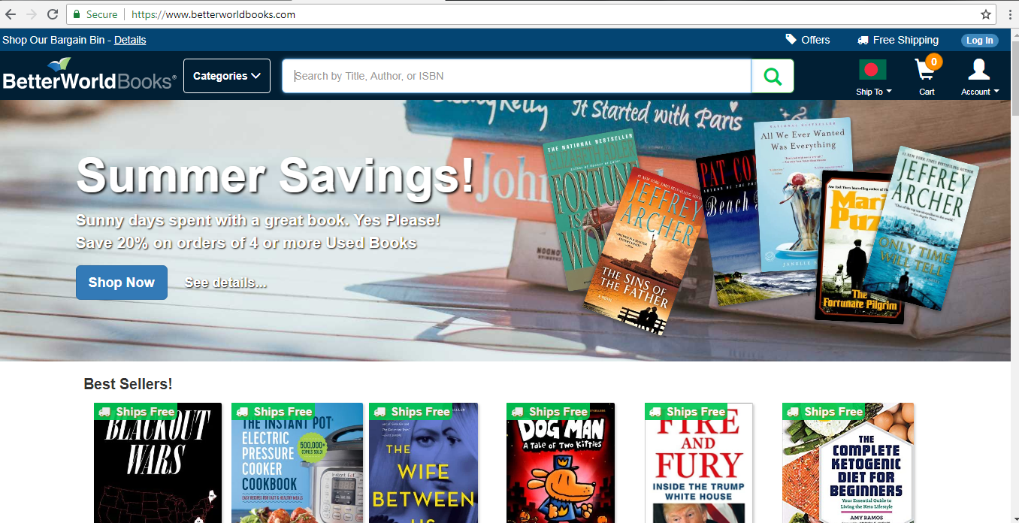

**BENCHMARK PRODUCT’S FEATURE**

Display:

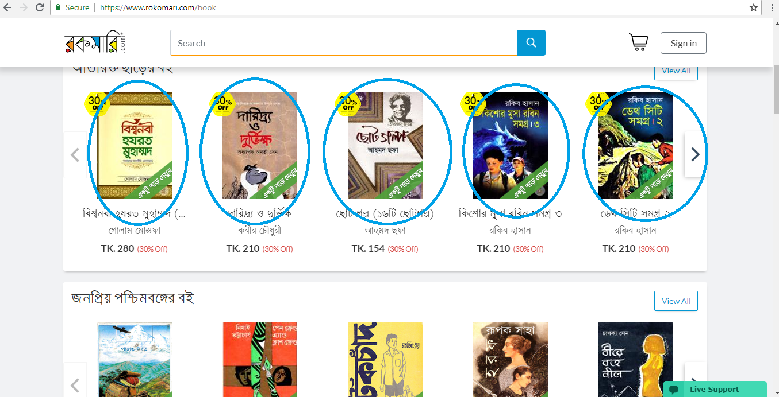

Book details:

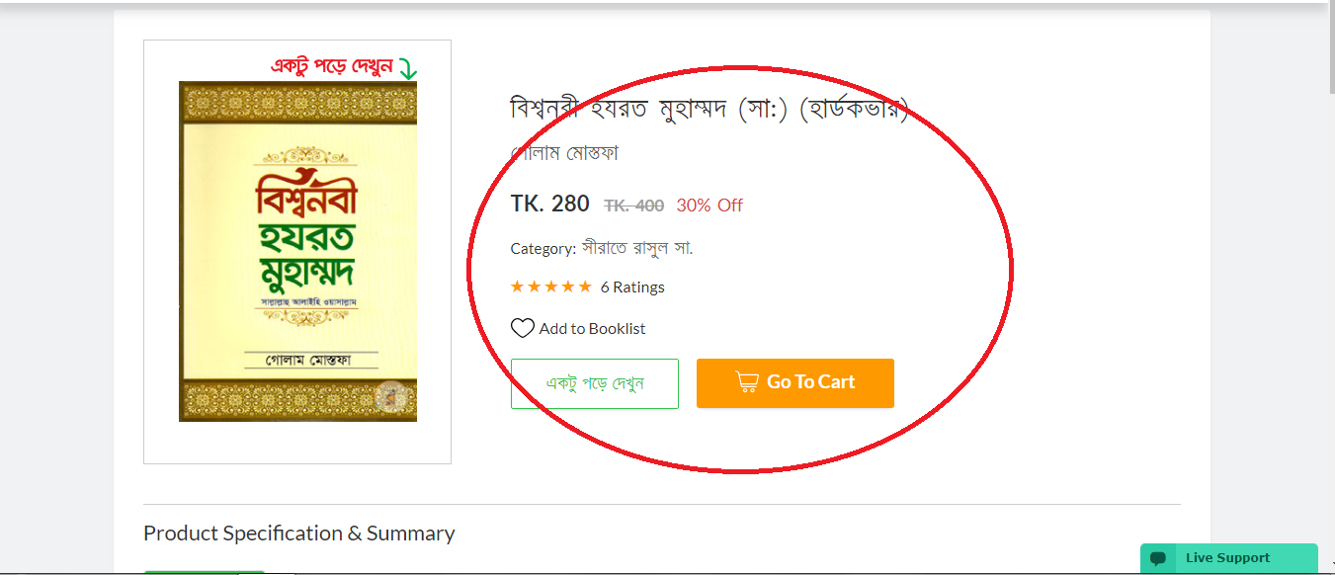

**BENCHMARK PRODUCT’S FEATURE: cart**

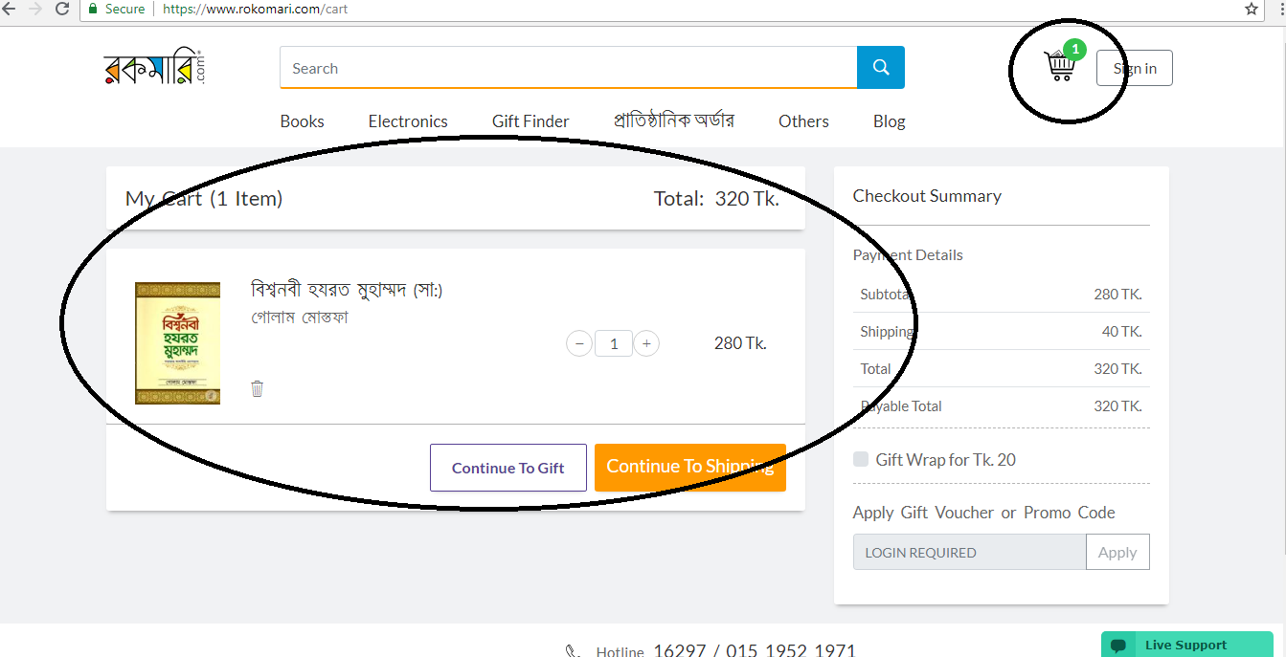

**BENCHMARK PRODUCT’S FEATURE: advertisement**

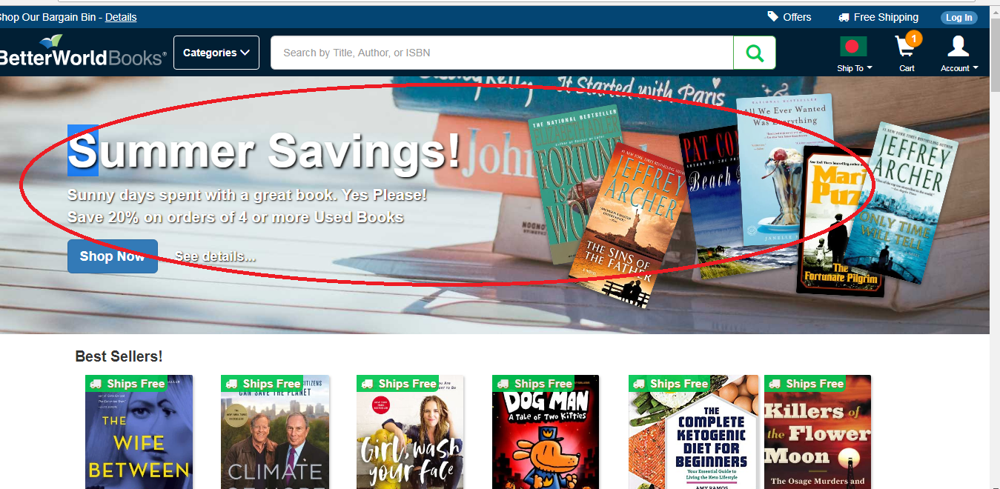

**BENCHMARK PRODUCT’S FEATUR: searching**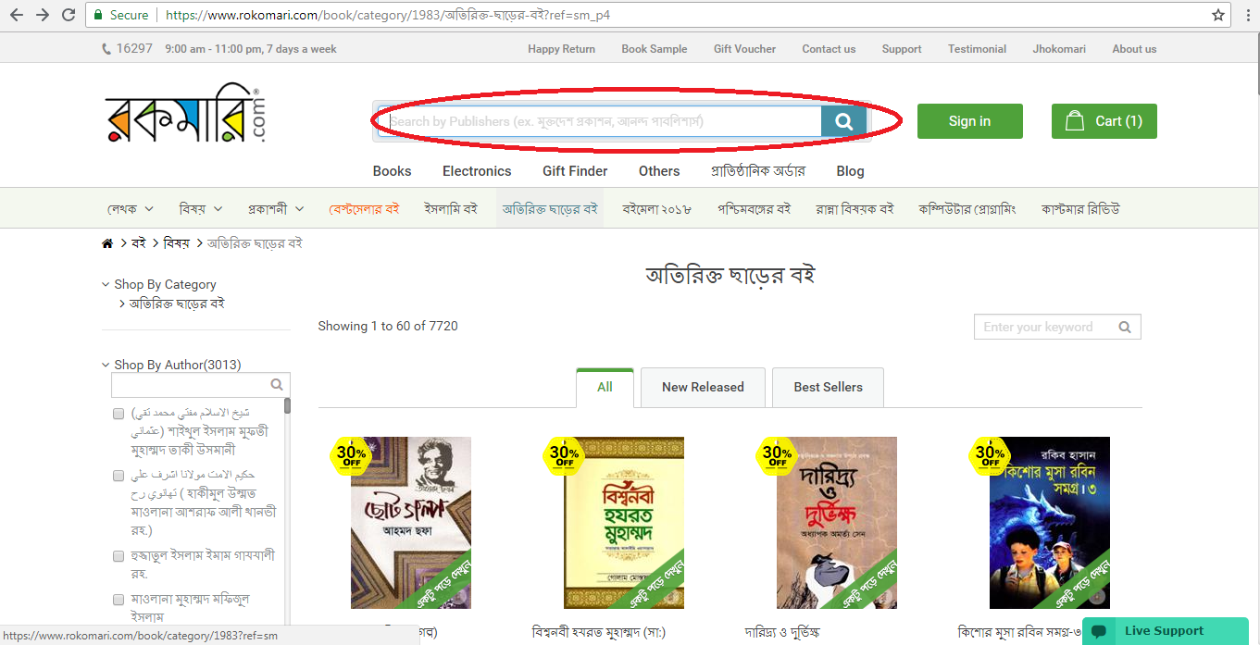

**BENCHMARK PRODUCT’S FEATURE: sign in**

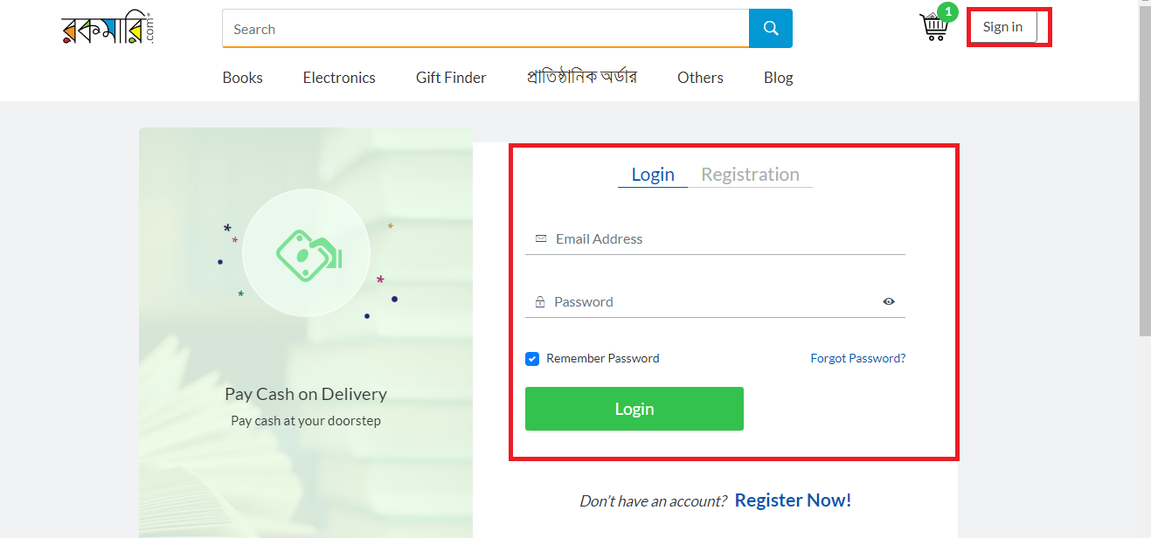

**List of benchmark features**

* BOOKS
* BOOK DISPLAY
* BOOK DETAILS
* CART
* ADVERTISEMENT
* SEARCHING
* PAYMENT POLICY
* SOCIAL MEDIA CONNECTION
* LOGIN SYSTEM

**TABLE OF BENCHMARK PRODUCTS**

|  |  |  |  |  |
| --- | --- | --- | --- | --- |
| **Features list** | **rokomari.com** | **Boibazar.com** | **Betterworldbooks.com** | **Proposed features** |
| **BOOK** | **✓** |  |  | **✓** |
| **Book display** | **✓** | **✓** | **✓** | **✓** |
| **cart** |  | **✓** | **✓** | **✓** |
| **Advertisement** | **✓** | **✓** | **✓** | **✓** |
| **searching** |  |  | **✓** |  |

**TABLE OF BENCHMARK PRODUCTS**

|  |  |  |  |  |
| --- | --- | --- | --- | --- |
| **Features list** | **rokomari.com** | Boibazar.com | **Betterworldbooks.com** | **Proposed features** |
| Payment policy |  | ✓ | ✓ | ✓ |
| Social media | ✓ | ✓ | ✓ | ✓ |
| Book details | ✓ | ✓ | ✓ | ✓ |
| Login system | ✓ | ✓ | ✓ | ✓ |

**List of extended features**

* Shipping place
* Shipping info
* Order status
* Contact info
* Site view
* Site review
* Discount
* Testimonials
* Similar books
* Shop by author/publisher/categories/title

**Features list:**

* BOOKS
* BOOK DISPLAY
* BOOK DETAILS
* CART
* ADVERTISEMENT
* SEARCHING
* PAYMENT POLICY
* SOCIAL MEDIA CONNECTION
* LOGIN SYSTEM
* Shipping place
* Shipping info
* Order status
* Contact info
* Site view
* Site review
* Discount
* Testimonials
* Similar books

**Site map home**

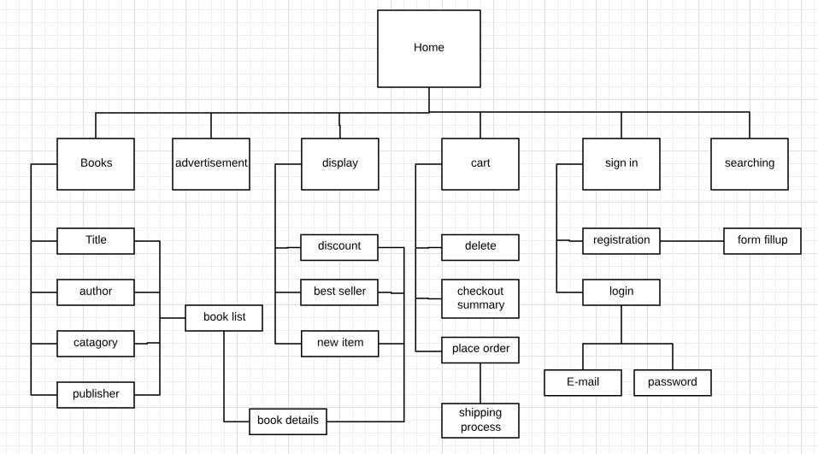

**Shipping process**

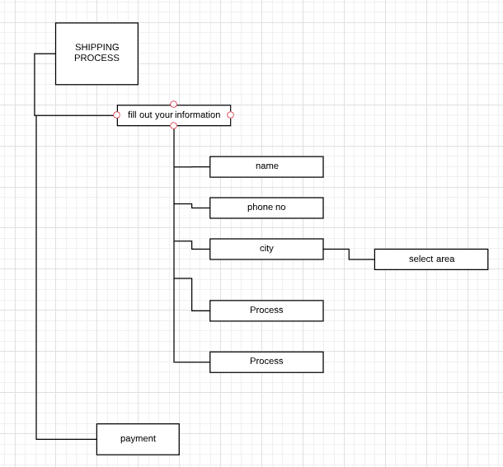

**Registration process**

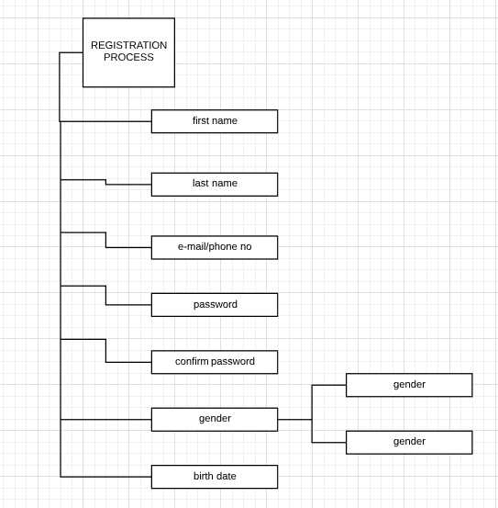

**Mock up of our web page: home**

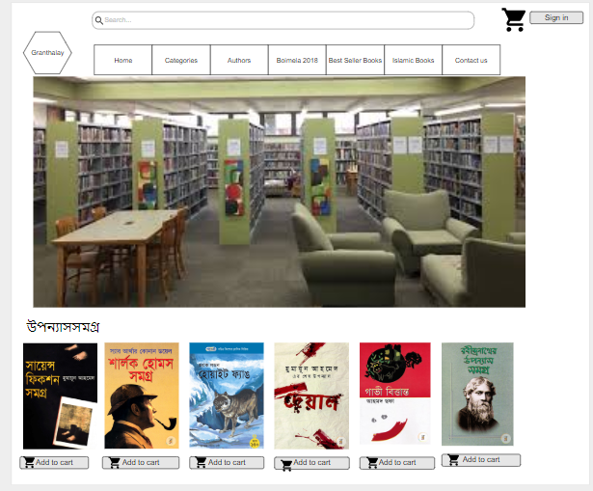

**Mock up of our web page: searching**

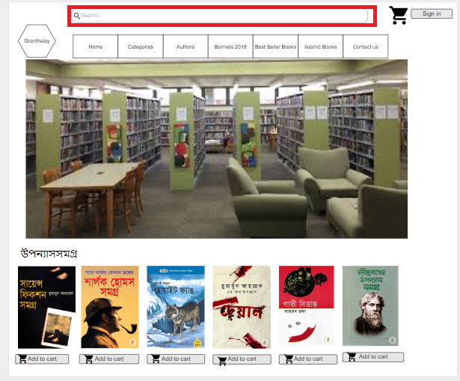

**Mock up of our web page: category**

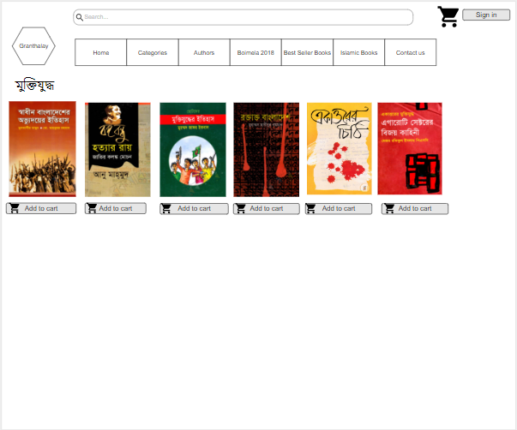

**Mock up of our web page: cart**

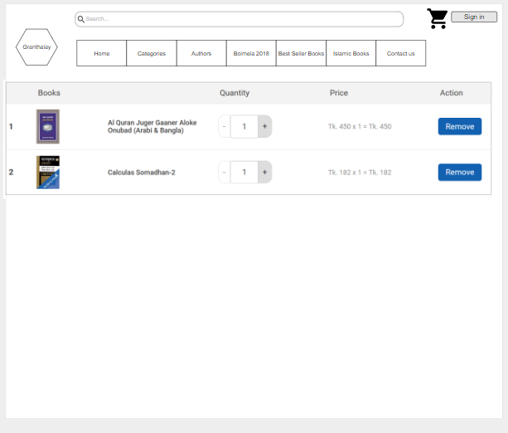

**Mock up of our web page: user login**

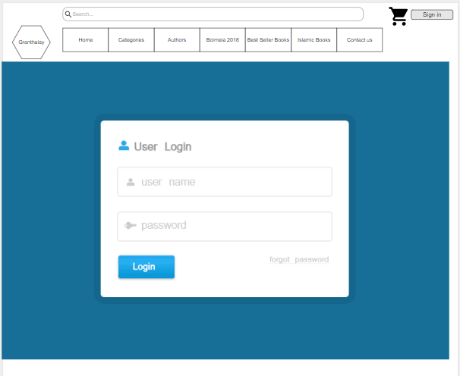

**Mock up of our web page: registration**

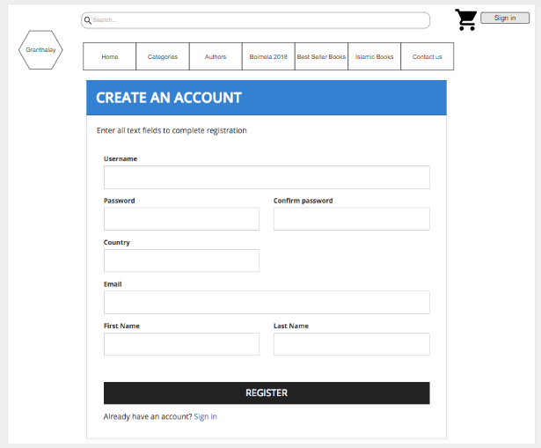

**Mock up of our web page: contact**

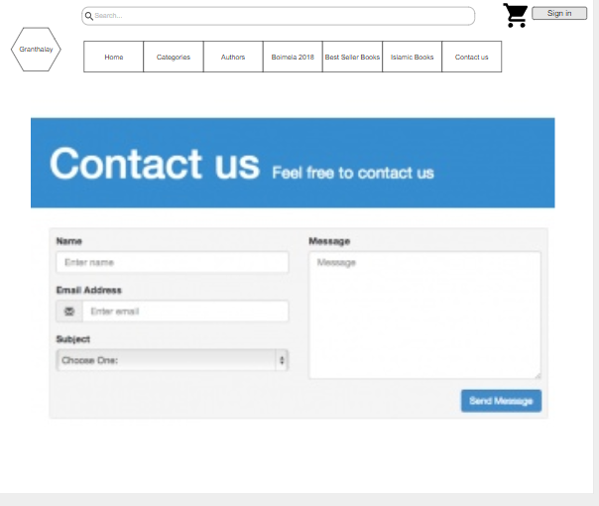

**Symbols of context diagram**

|  |  |  |
| --- | --- | --- |
| **element** |  | **symbol** |
| Process | 1. Contains a number and name  2. Data flows in or out |  |
| Data flow | 1. Contains a name/description |  |
| External entities | 1. Contains a name |  |

**Rules of context diagram**

* process contains a number and name. Data flows in or out.
* External entities should written in capital letter.
* It shows basic overview of the whole system.

**Context diagram**

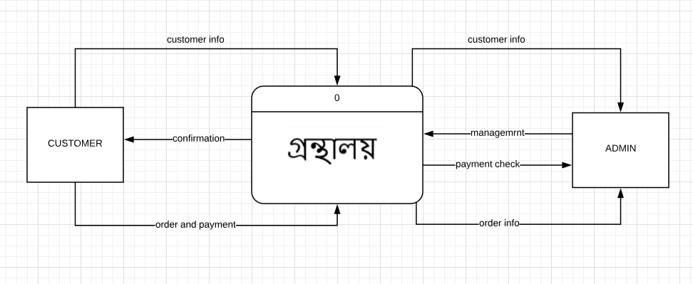

**Symbols of data flow diagram**

|  |  |  |
| --- | --- | --- |
| **element** |  | **Symbols** |
| process | 1. Contains a number and name  2. Data flows in or out |  |
| Data flow | 1. Contains a name/description |  |
| Data store | 1. Contains a number and a name  2. Data flows in or out |  |
| External entities | 1. Contains a name |  |

**Rules of data flow diagram**

* Each process has name and number.
* Database will be named in capital letter.
* Start from top left and ended at right bottom.
* Database and external entities will be connected with process only.
* Database-database, external entity-database, external entity to external entity connection is not allowed.

DATA FLOW DIAGARAM

LEVEL 1:

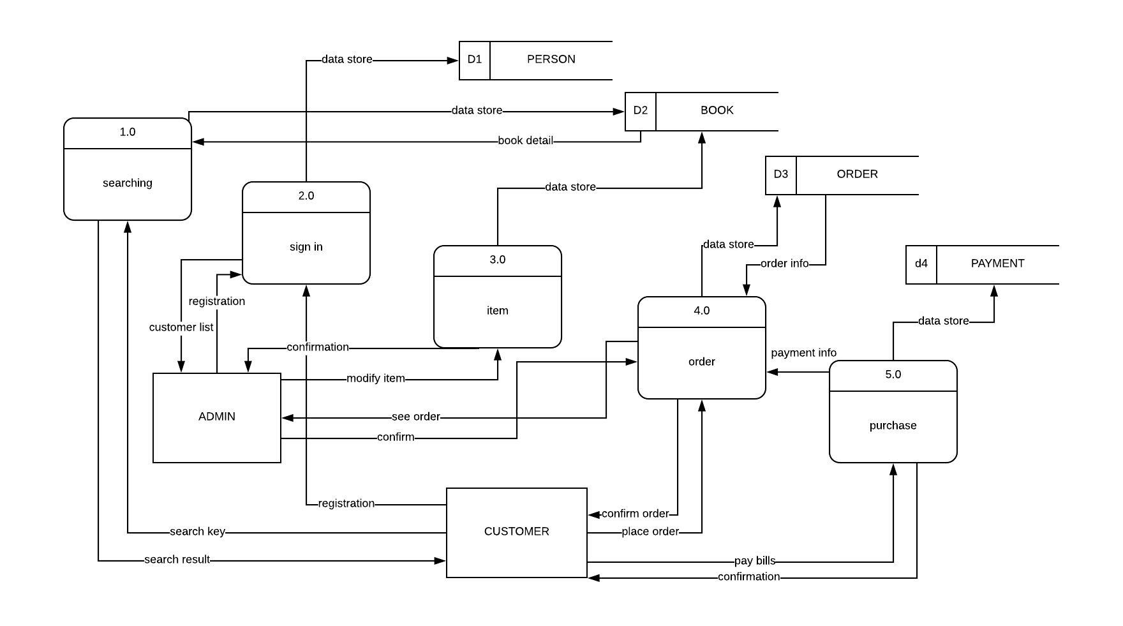

LEVEL 2:SIGN IN

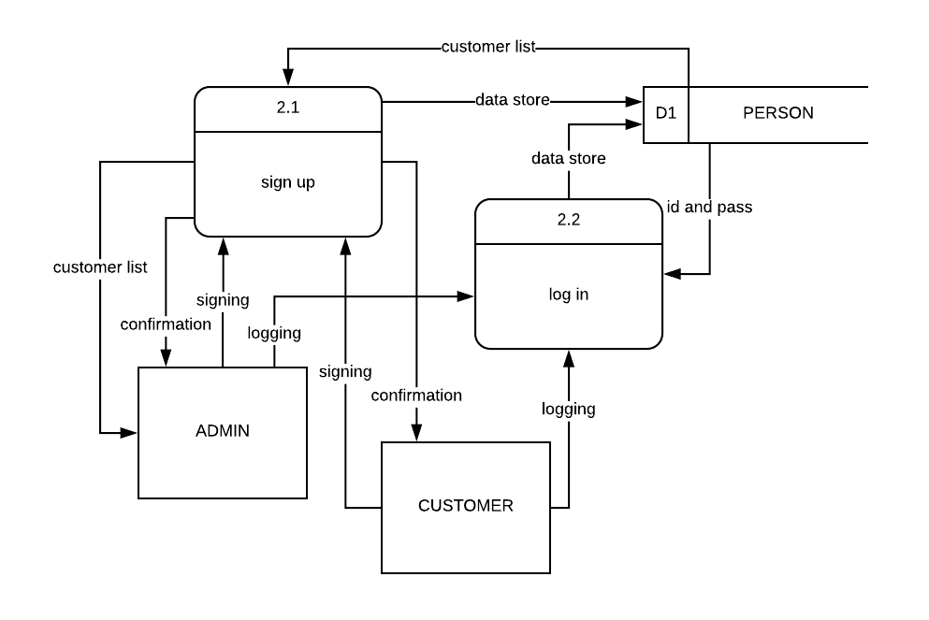

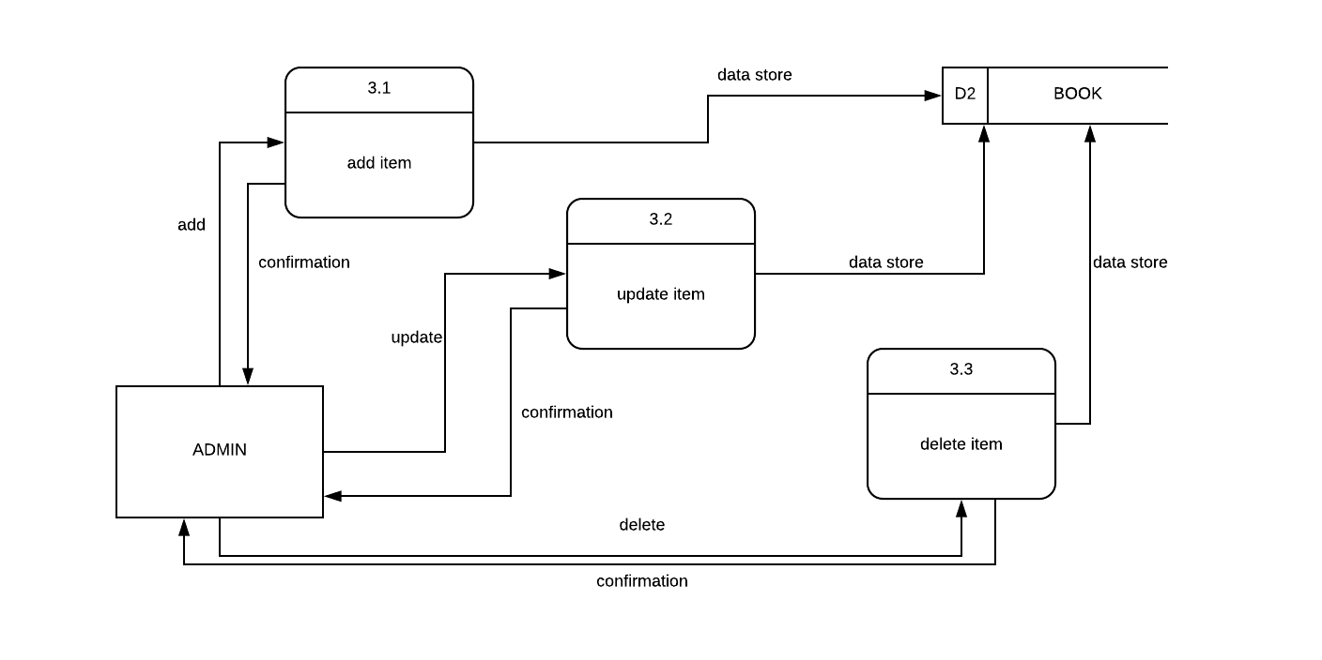LEVEL 3: ITEM

LEVEL 4: ORDER

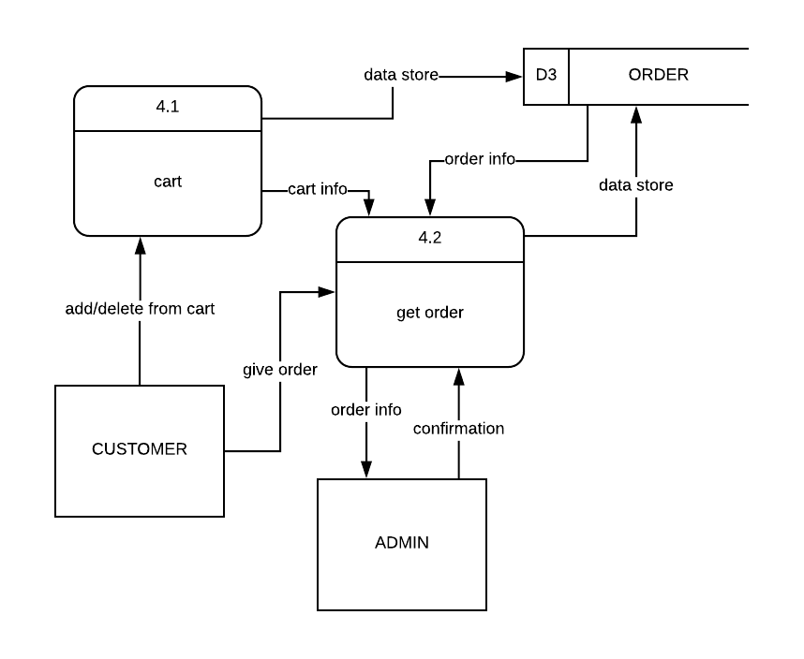

LEVEL 5: GET ORDER FROM ORDER PROCESS

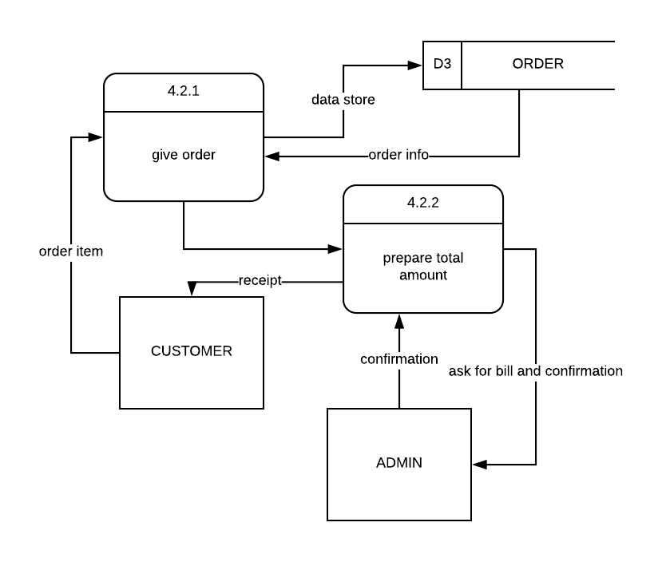

**LEVEL 6: CART FROM ORDER PROCESS**

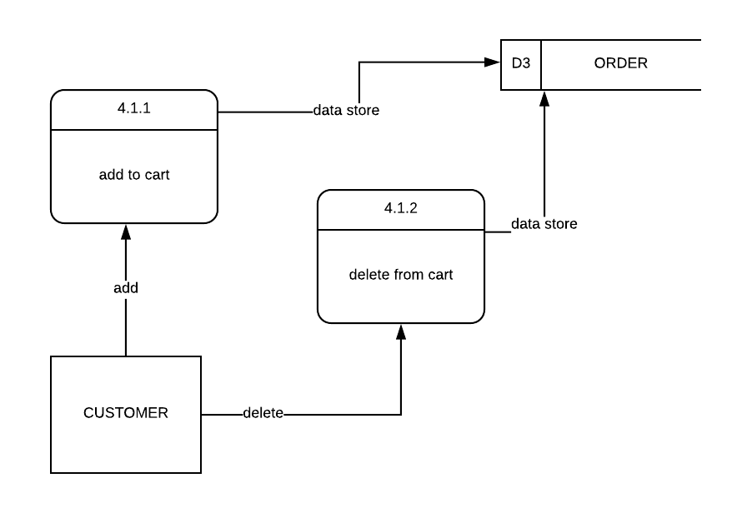

LEVEL 7: PURCHASE

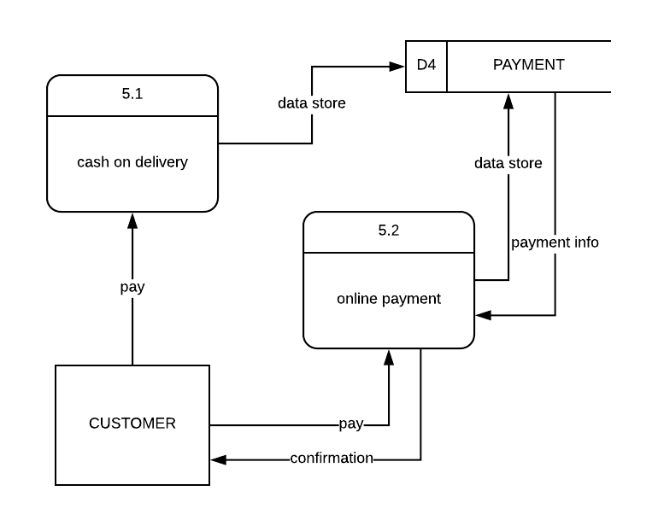

SYMBOLS OF ACTIVITY DIAGRAM

|  |  |
| --- | --- |
| **Elements** | **Symbols** |
| Start point |  |
| Activity |  |
| Action flow |  |
| Decision symbol |  |
| End point symbol |  |

RULES OF ACTIVITY DIAGRAM:

1. The start point is placed in the top left corner of the first column.
2. The outgoing alternates should be labeled with a condition or guard expression.
3. End point symbol: Marks the end state of an activity and represents the completion of all flows of a process

ACTIVITY DIAGRAM FOR CUSTOMER

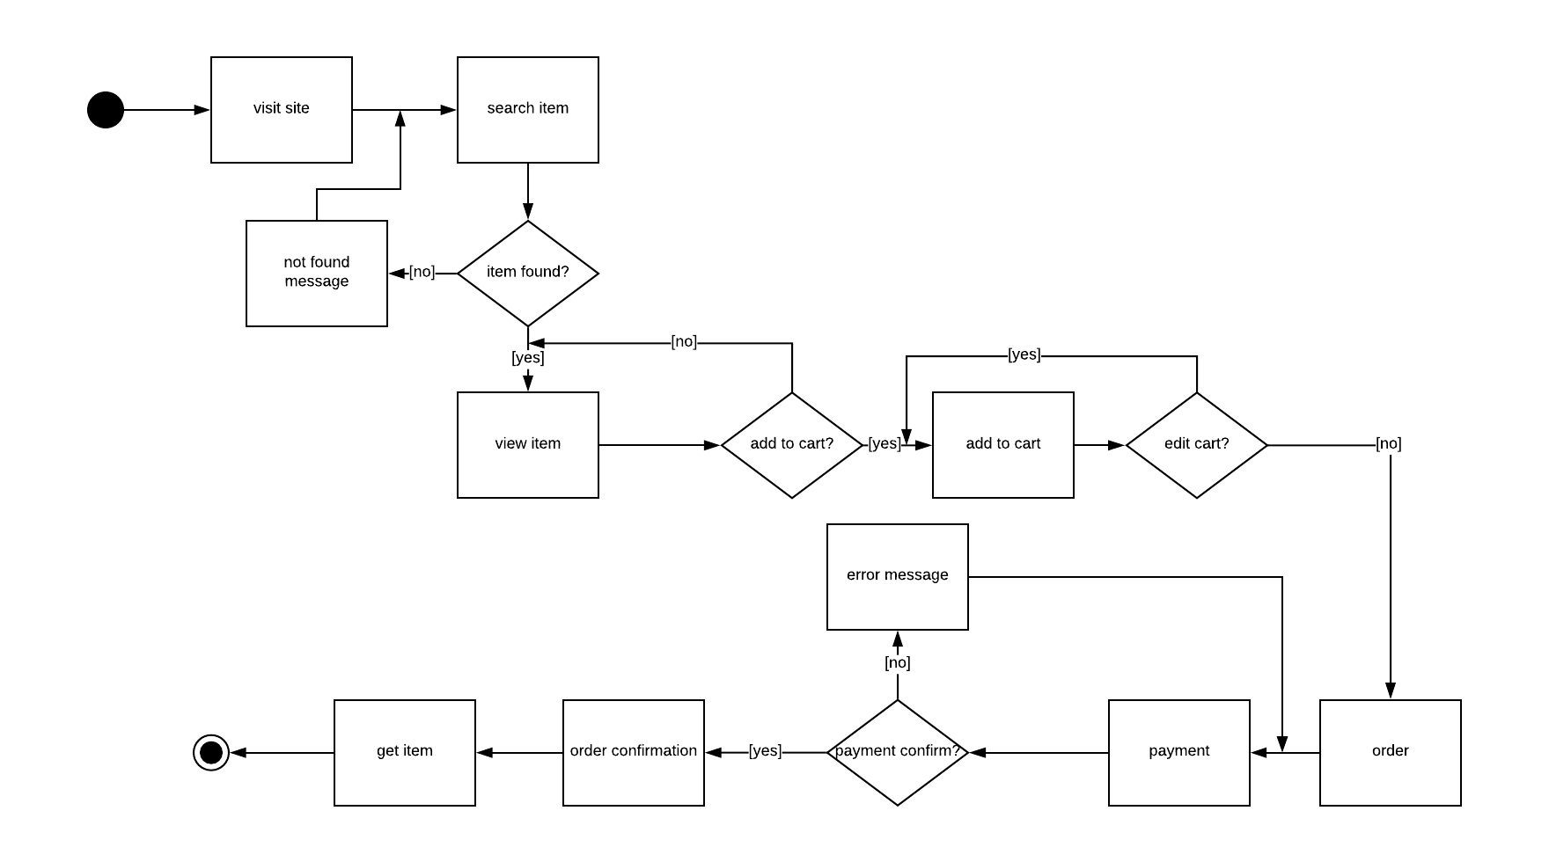

ACTIVITY DIAGRAM FOR ADMIN

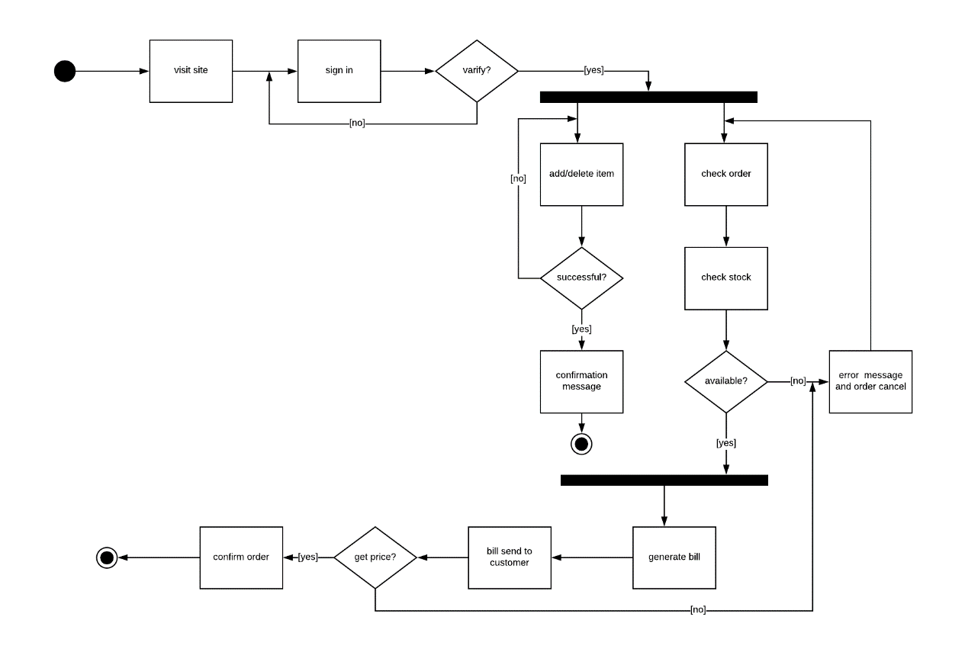

SYMBOLS OF SWIM LANE DIAGRAM

|  |  |
| --- | --- |
| **Elements** | **Symbols** |
| Start point |  |
| Activity |  |
| Action flow |  |
| Decision symbol |  |
| End point symbol |  |
| Swim lane |  |

RULES OF SWIM LANE DIAGRAM

1. A flavor of activity diagram, which also give information about which role is performing the underlying activity.
2. Activity diagram is divided into multiple column in dedicated to a particular role.

SWIM LANE DIAGRAM

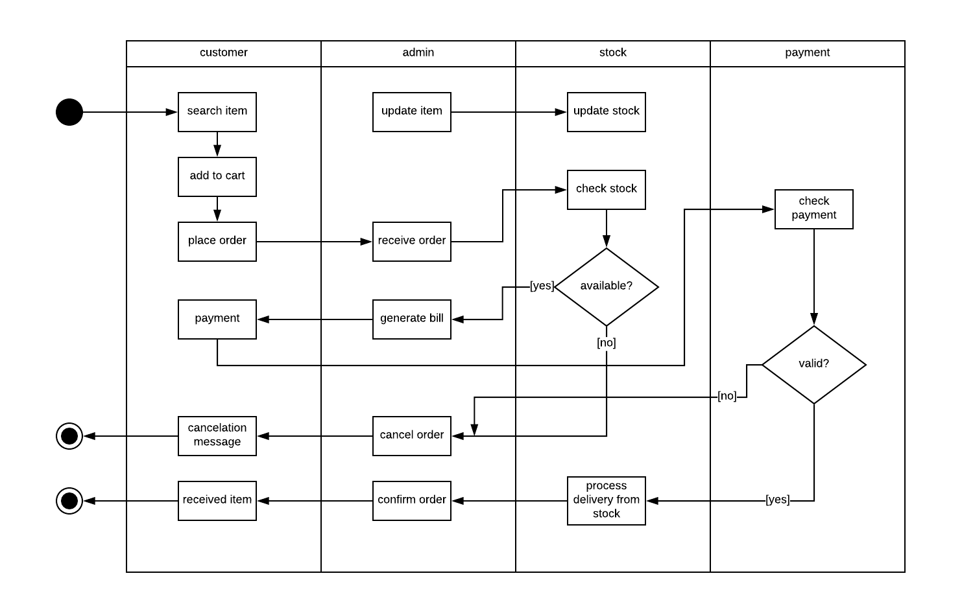

SYMBOLS OF USE CASE DIAGRAM

|  |  |  |
| --- | --- | --- |
| **element** |  | symbols |
| Use case | Contains feature/task |  |
| actor | Anyone who interacts with the  system (person, organization,  external device, etc.) |  |
| Relationship | Relation between actor and use  case |  |
| System | The whole system |  |

USE CASE DIAGRAM CONCEPT

|  |  |  |
| --- | --- | --- |
| **Include** | Use Case 2 will occur when  Use Case 1 is processed. |  |
| extend | Use Case 2 may or may not  occur when Use Case 1 is  Processed. |  |
| generalization | Inheritance |  |

RULES OF USE CASE DIAGRAM

1. At least one use case
2. At least one actor.
3. No label any association line.
4. Names begin with a verb
5. Make the name descriptive
6. Highlight the logical order
7. Place included use cases to the right of the invoking use case
8. Place inheriting use case below parent use case

USE CASE DIAGRAM

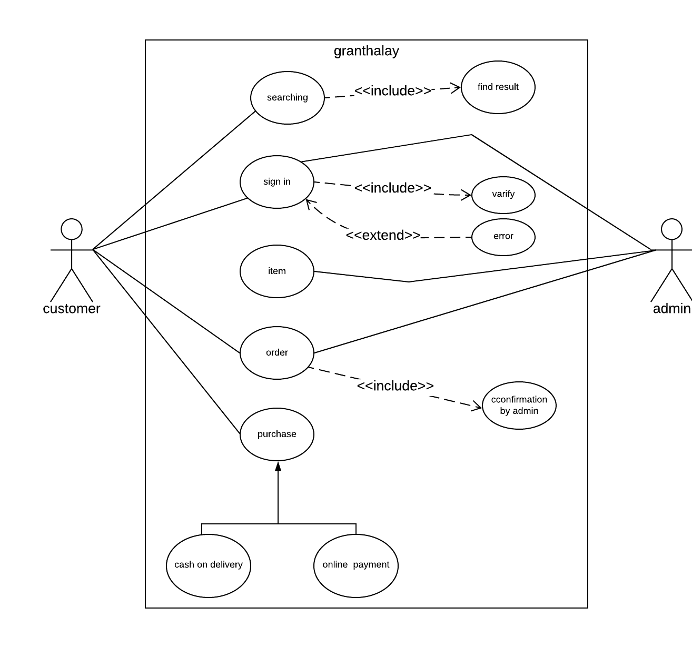

**USE CASE DISCRIPTIVE FORM for customer**

|  |  |
| --- | --- |
| **Use case 01** | **Buy a product** |
| Primary actor | Customer |
| Stakeholder and interests | 1. customer: to buy a product successfully 2. Admin: need to make sure that customer can buy successfully |
| Preconditions | 1. Customer must have a name and address, 2. Customer should know the site address |
| Post conditions | 1. The documents of transaction remains even after the process end 2. Change are made in database 3. The customer can see the order summary |
| Main success scenario | 1. Customer goes to the site 2. Customer finds the desired item 3. Can buy the item successfully |

|  |  |
| --- | --- |
| **Alternate scenario** | **\*a.** The system may not respond  *Solution:* Wait for the system to respond  **2.a) customer may not find the desired item**  **Solution: need to contact the admin**  **3.a) can not buy item successfully**  **Solution: need to report some problem** |
| Issues | If payment is not clear, error message will be shown |

**USE CASE DISCRIPTIVE FORM for admin**

|  |  |
| --- | --- |
| **Use case 02** | **Manage the site** |
| Primary actor | Admin |
| Stakeholder and interests | Admin: manage the site successfully  Customer: buy product successfully |
| Preconditions | 1. Must be a registered admin 2. must have a name and id |
| Post conditions | 1. Change made in the database after update something 2. Can see the payment from customer |
| Main success scenario | 1. Go to the site 2. Update something 3. Manage the orders from customers |
| Alternate scenario | *a. The system may not respond  Solution: Wait for the system to respond |
| Issues | If something is went wrong then error message will be shown |

**Feasibility Study**

* Financial Feasibility
  + Cash Flow Analysis
    - Our online community is totally free to join
    - Expenses : Maintenance cost for domain and hosting
    - Revenues : Donations can be considered as revenue
* Technical Feasibility
  + As it is a website, so the site is accessible from any internet supported device like desktop/laptop/mobile/tab etc.
  + No special hardware requirements, negotiable resources will be enough to use the site.
  + As users can simply browse the site like other sites, so no extra load on operating system.
* Behavioral Feasibility
  + The site is very user friendly and informative
  + No complexity when surfing the site, navigation is very simple but modern

**Total Expenses**

|  |  |  |  |  |  |
| --- | --- | --- | --- | --- | --- |
| **Month** | **Present** | **3rd** | **6th** | **9th** | **12th** |
| **Domain** | **1000** | **0** | **0** | **0** | **0** |
| **Hosting** | **2500** | **0** | **0** | **0** | **0** |
| **Office Rent** | **12000** | **36000** | **36000** | **36000** | **36000** |
| **Web Design** | **20000** | **0** | **0** | **0** | **0** |
| **Utilities** | **10000** | **10000** | **10000** | **10000** | **10000** |
| **Electricity** | **1000** | **3000** | **4000** | **3500** | **3000** |
| **Internet** | **5000** | **15000** | **15000** | **15000** | **15000** |
| **Total** | **51500** | **64000** | **65000** | **64500** | **64000** |

**Total Revenue**

|  |  |  |  |  |  |
| --- | --- | --- | --- | --- | --- |
| **Month** | **Present** | **3rd** | **6th** | **9th** | **12th** |
| Advertisement | 20000 | 20000 | 60000 | 90000 | 100000 |
| Viewer | 10000 | 20000 | 15000 | 10000 | 10000 |
| Total | 30000 | 40000 | 75000 | 100000 | 110000 |

**Cash Flow**

|  |  |  |  |  |  |
| --- | --- | --- | --- | --- | --- |
| **Month** | **Present** | **3rd** | **6th** | **9th** | **12th** |
| Total Expenses | 51500 | 64000 | 65000 | 64500 | 64000 |
| Total Revenue | 30000 | 40000 | 75000 | 100000 | 110000 |
| Cash Flow(revenue-expenses) | (21500) | (24000) | 10000 | 35500 | 46000 |
| Accumulating Cash Flow | (21500) | (45500) | (35500) | 0 | 46000 |

**SWOT ANALYSIS**

Strengths

* Low-cost leadership.
* Strong relationship with client.
* Easy to navigate through the website
* Continued personalized service.

**Weakness**

**\* delivery problem**

**\* lack of employee**

**\* unable to calculate profit for this business**

Opportunities

* New challenges.
* Expanding sector with many opportunities for success.
* Competitors slow to adapt to new technologies.
* Self-employment.
* Introducing with new technologies.

Threats

* List of all the factors that have the potential to reduce our organization’s performance .

* Loss of internet access due to weather.

* Competitive industry funding.

**Conclusion**

Online book store is an online website where the customer can purchase books online through a web browser the customers can search for a book by its title or author, later can add to shopping cart and finally purchase the book